Uber Design

Contents
Chapter_1 >> The Problem
1.the problem description
2. requirements
3.Needed API endpoints
Chapter_2 >> The Solution
1.Data Model
2.High level Design

Chapter 1
1.1 The problem
Uber is a ride-hailing service where a rider requests a ride, the system estimates the fare, finds nearby available drivers, and matches one to the rider. During the trip, the system tracks the driver's real-time location and streams updates to the rider's map. The trip moves through a lifecycle of states—searching, matched, in progress, completed—with each transition triggering side effects like notifications, fare metering, and payment.

1.2 Functional requirements
___________________________
1.Estimate the fare.
2.Finds nearby available drivers, and matches one to the rider.
3.Tracks Driver and rider real time Location and so the trip location.
4.Moves through States of progress

1.3 Scale requirements
______________________________________________
1.Assuming 32 millions of daily riders
2.Assuming 5 millions of drivers , at most 2 millions active at peak hours.
3.Ride matching each 5 seconds
4.Update locations each 10 seconds with 2 million driver so system handles 200 000 writes per second
5.update user location each 50 seconds so system should handle another 50 000 writes per seconds

1.4 non functional requirements
1.consistency >> unique driver assignment to trip
2.atomiciy needed for transitions , persistent records .
3.millions of users sends GPS pers seconds
4.sub seconds search
5.consistent lifecycle

1.5 Data Model

1.6 API endpoints Needed
________________________________________

GET API/rides/:id/estimate
POST API/rides >> Request a ride ,and make a ride returning the id of this ride .
GET API /rides/:id >> Status of ride
PUT API/drivers/:id
PUT API/users/:id >>update location ,etc
PUT API/rides/:id >> update state ,etc
//
PUT API/rides/offer/:id/action >>Cancel or accept
PUT API/rides/cancel/:id >>Cancel Trip by user

Chapter 2 : the solution
2.1 High level design

Tracking and finding Match
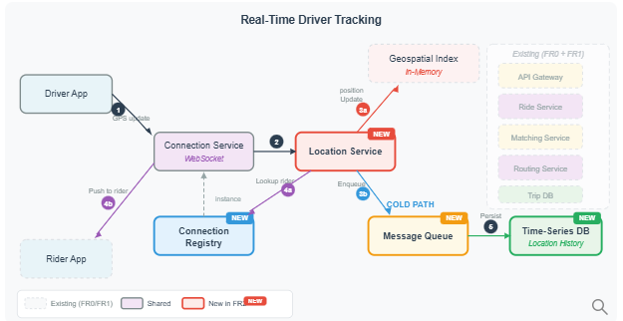
The Location Service receives GPS updates from the Connection Service and splits them into two paths: the hot path updates the in-memory Geospatial Index for real-time matching, while the cold path sends updates through a Message Queue to a Time-Series DB for durable history. To relay location to riders, the Location Service consults the Connection Registry to find which Connection Service instance holds the rider's WebSocket. All previous components (API Gateway, Ride Service, Matching Service) remain unchanged.

Full Architecture
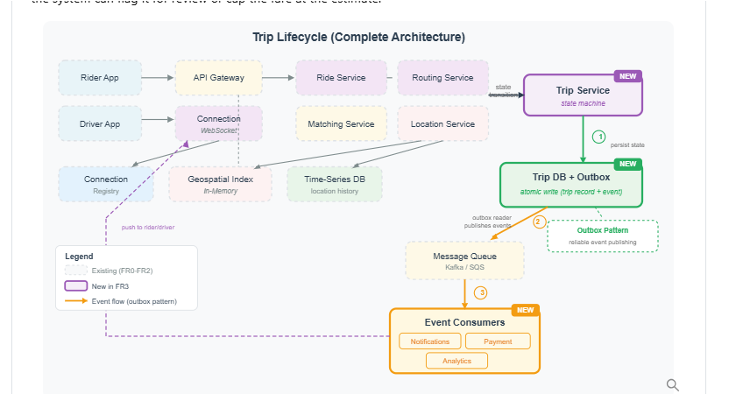

I considered design in this src with some changes :
Design Uber | System Design Interview Question
The changes will be added here once I finish the project

